

Semester One Examination, 2022

Question/Answer booklet

MATHEMATICS SPECIALIST
UNIT 3

Section One:

Calculator-free

Your Name

Your Teacher’s Name

Time allowed for this section
Reading time before commencing work: five minutes
Working time: fifty minutes

Materials required/recommended for this section
To be provided by the supervisor
This Question/Answer booklet
Formula sheet

To be provided by the candidate
Standard items: pens (blue/black preferred), pencils (including coloured), sharpener, correction fluid/tape, eraser, ruler, highlighters

Special items: nil

Important note to candidates
No other items may be taken into the examination room. It is your responsibility to ensure that you do not have any unauthorised material. If you have any unauthorised material with you, hand it to the supervisor before reading any further.
Question | Mark | Max | Question | Mark | Max
1 |  |  | 5
2 |  |  | 6
3 |  |  | 7
4 |  |  | 8

Structure of this paper

Section | Number of questions available | Number of questions to be answered | Working time (minutes) | Marks available | Percentage of examination
Section One:  Calculator-free | 8 | 8 | 50 | 52 | 34
Section Two:  Calculator-assumed | 14 | 14 | 100 | 97 | 65
 |  |  |  | Total | 100

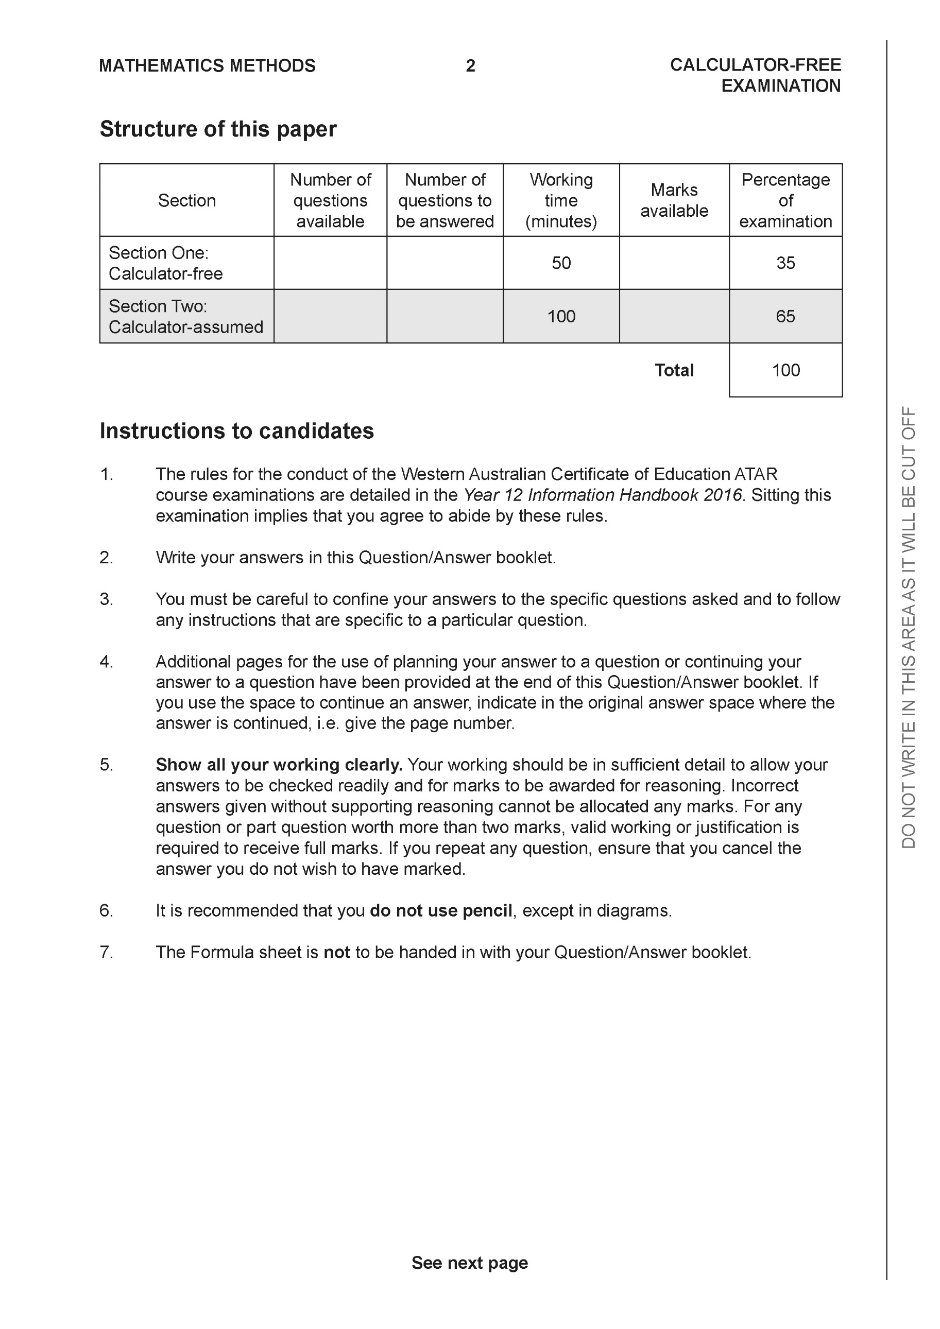

Section One: Calculator-free (52 Marks)

This section has eight (8) questions. Answer all questions. Write your answers in the spaces provided.

Spare pages are included at the end of this booklet. They can be used for planning your responses and/or as additional space if required to continue an answer.
● Planning: If you use the spare pages for planning, indicate this clearly at the top of the page.
● Continuing an answer: If you need to use the space to continue an answer, indicate in the original answer space where the answer is continued, i.e. give the page number. Fill in the number of the question that you are continuing to answer at the top of the page.

Working time: 50 minutes.

Question 1 (4 marks)

Consider the complex number as plotted on the complex plane below.

- Determine the exact value of and plot on the axes above. (2 marks)

Solution
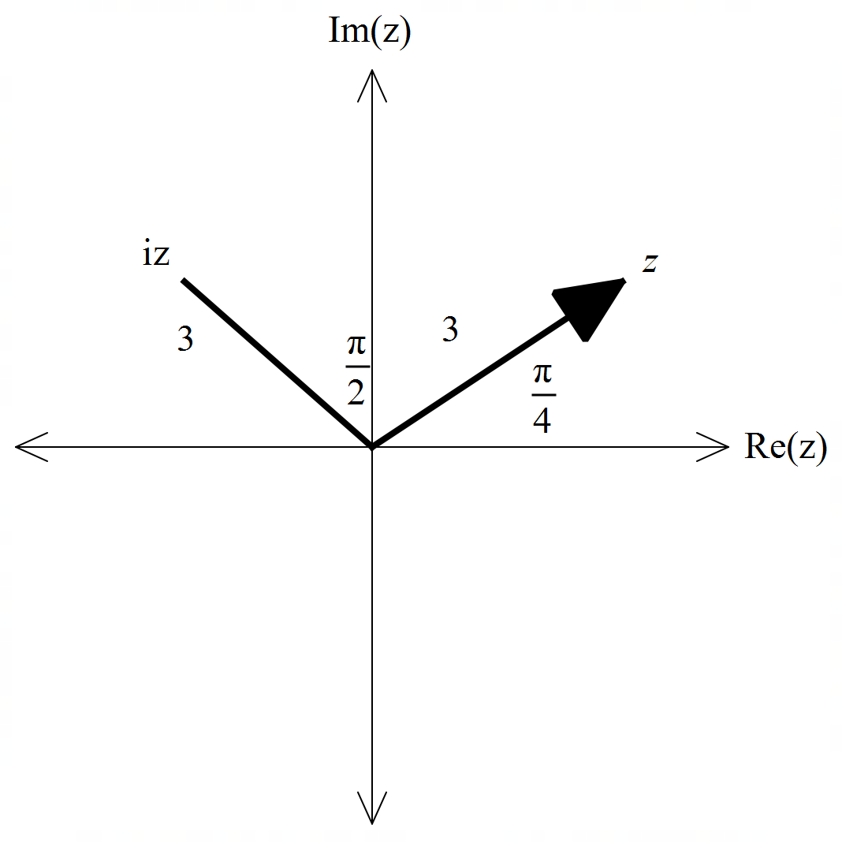

Specific behaviours
P uses rotation of 90 degrees
P states argument

- Determine the exact value of. (2 marks)

Solution
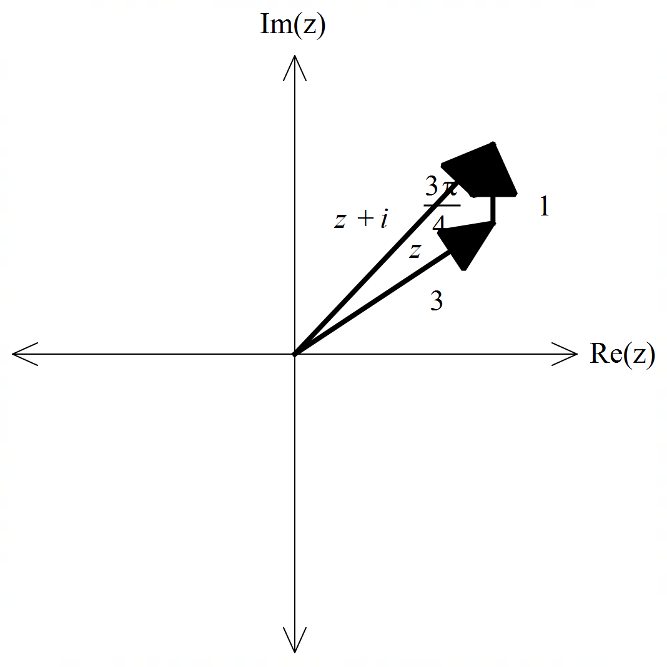

Specific behaviours
P uses triangle rule
P states exact value that must be simplfied

Question 2 (8 marks)

Consider the functions with domains shown in the graphs below.
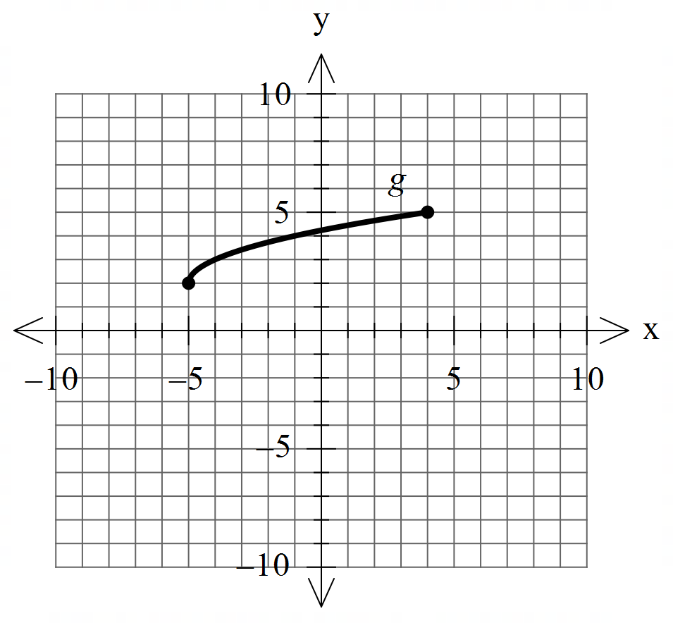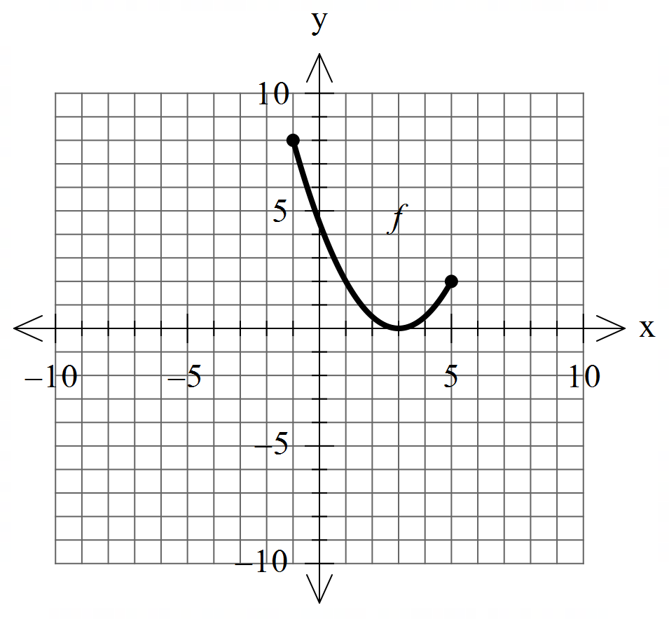

- Sketch the inverse functions above.
If they exist. (2 marks)

Solution
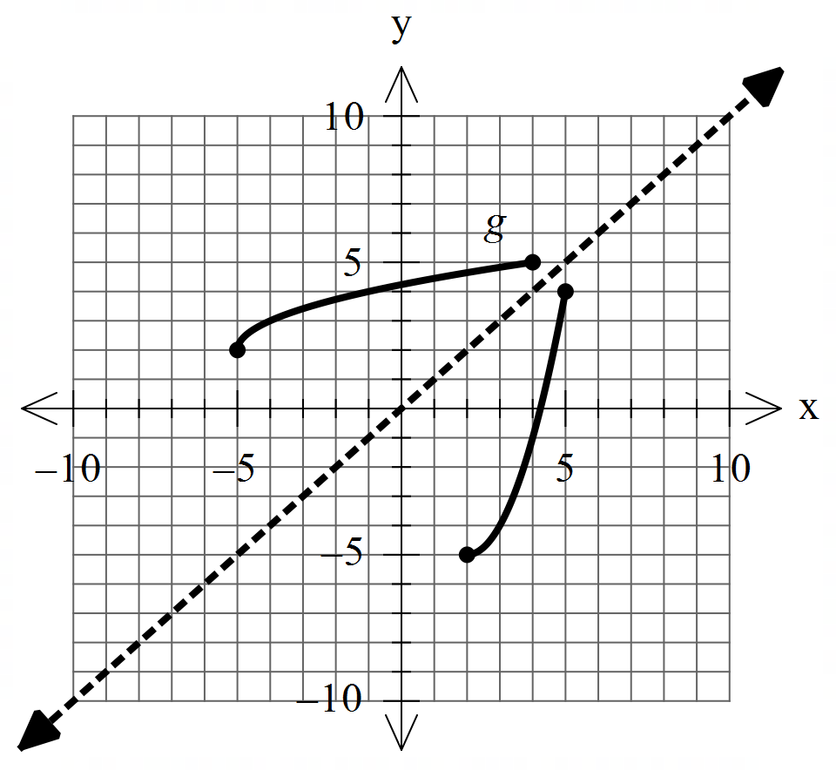

Specific behaviours
P states that f does not exist
P sketches inverse of g with correct endpoints

- Which of the following exist over natural domains, , ? Explain.
State the natural domain and corresponding ranges for those that exist. (3 marks)

Solution
Specific behaviours
P states domain and ranges of both functions in argument
P shows that fog exists with condition
P shows that gof does not exist with condition

- The rule for is . State the inverse rule and its domain. (3 marks)

Solution
Specific behaviours
P swaps x & y
P solves for inverse
P states domain

Question 3 (5 marks)

Consider the function .
Plot on the axes below labelling intercepts and asymptotes.

Solution
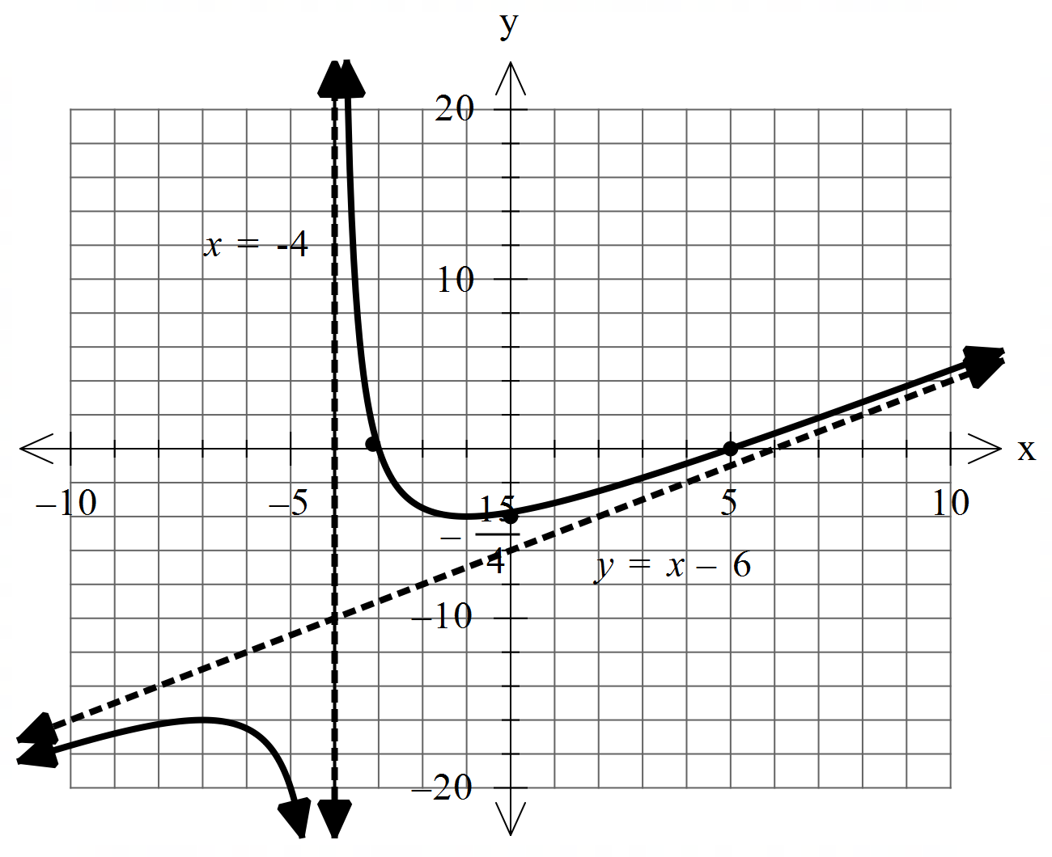

Specific behaviours
P shows and labels vertical asymptote
P shows and labels oblique asymptote (accept y=x)
P shows and labels x intercepts
P shows and labels y intercept
P shape is correct

Question 4 (8 marks)

Consider the polynomial for the complex variable .

- Given that , determine a quadratic factor of . (3 marks)

Solution
Specific behaviours
P uses conjugate
P correct coefficient of x
P correct quadratic factor

- If , determine all solutions to . (2 marks)

Solution
Specific behaviours
P states 2 solns
P states all 4 roots

- can be expressed as where are real integers. Determine the values of . (3 marks)

Solution
Specific behaviours
P uses conjugate of -2-i
P uses a=3
P states both quadratic factors

Question 5 (7 marks)

Consider the function .
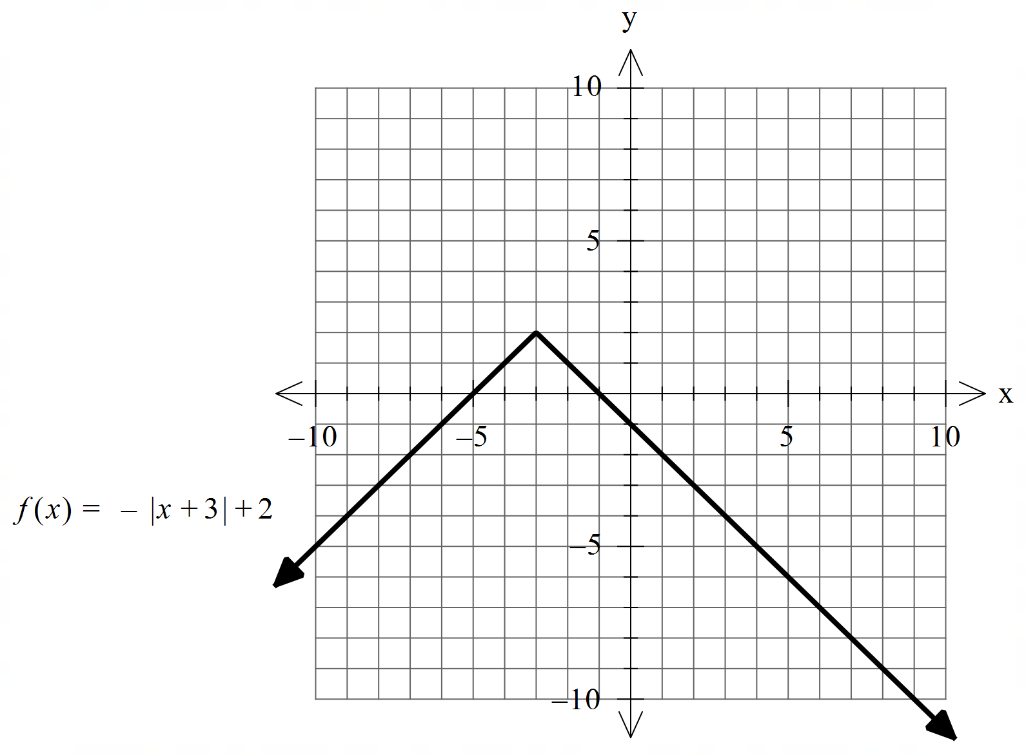

- Sketch on the axes below, labeling important features. (4 marks

Solution
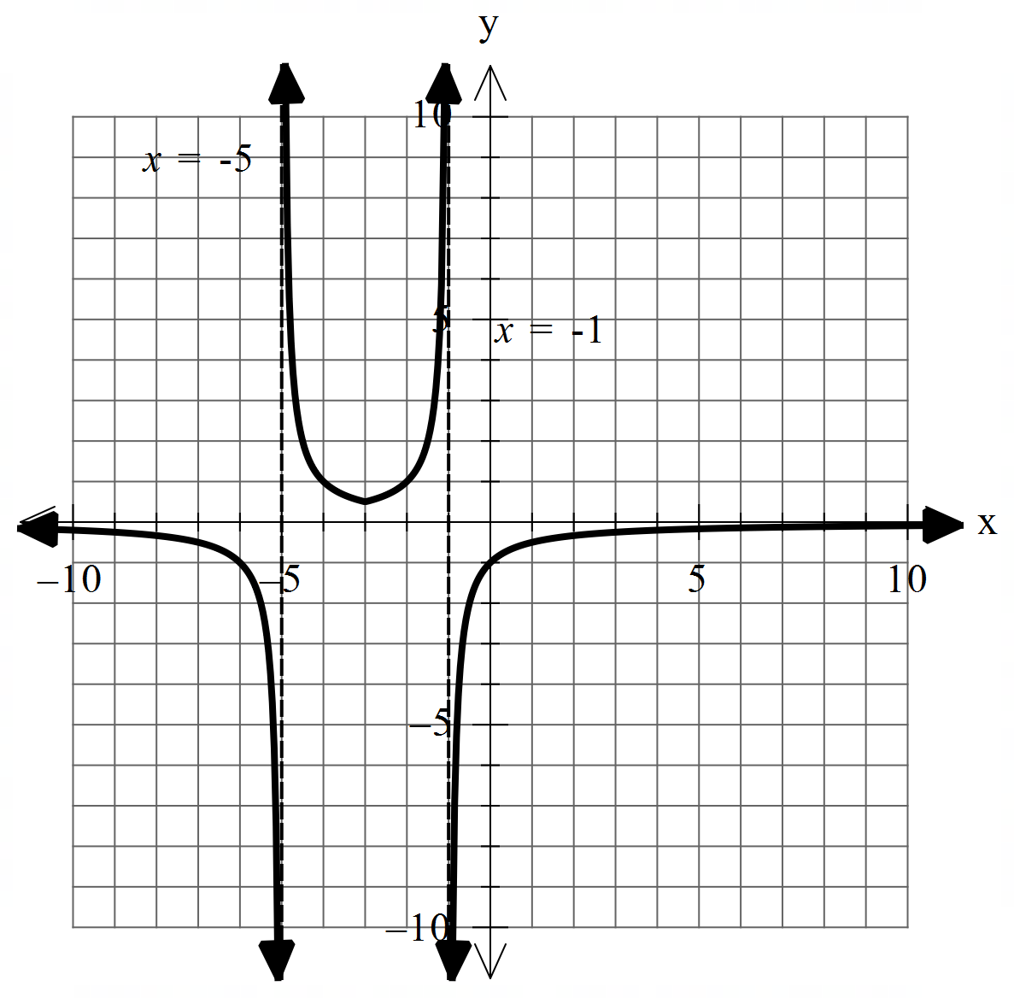

Specific behaviours
P shows and labels both asymptotes
P y intercept is -1, (no need to label)
P x axis appears to be an asymptote
P correct shape with turning point (-3,0.5)

- Hence determine the natural domain and range of (3 marks)

Solution
i.e Range of g is all Real numbers excluding
i.e
Specific behaviours
P shows use of factor -1/3 and graph in (a) or other stated reasoning
P states domain
P states range

Question 6 (6 marks)

Consider the linear equations

- Solve for . (3 marks)

Solution
Specific behaviours
P eliminates one variable from two equations
P eliminates two variables from one equation
P solves for all unknowns

- Consider the following system where are constants. (3 marks)
Solve for all possible values of for the following scenarios:
- Unique solution
- Infinite solutions
- No solutions.

Solution
Specific behaviours
P obtains an equation with two variable eliminated and in terms of p&q
P states requirement for uniqueness
P states requirements for infinite and no solns

Question 7 (10 marks)

Consider the function for which is plotted below.

- Sketch the inverse function on the axes above. (2 marks)
- 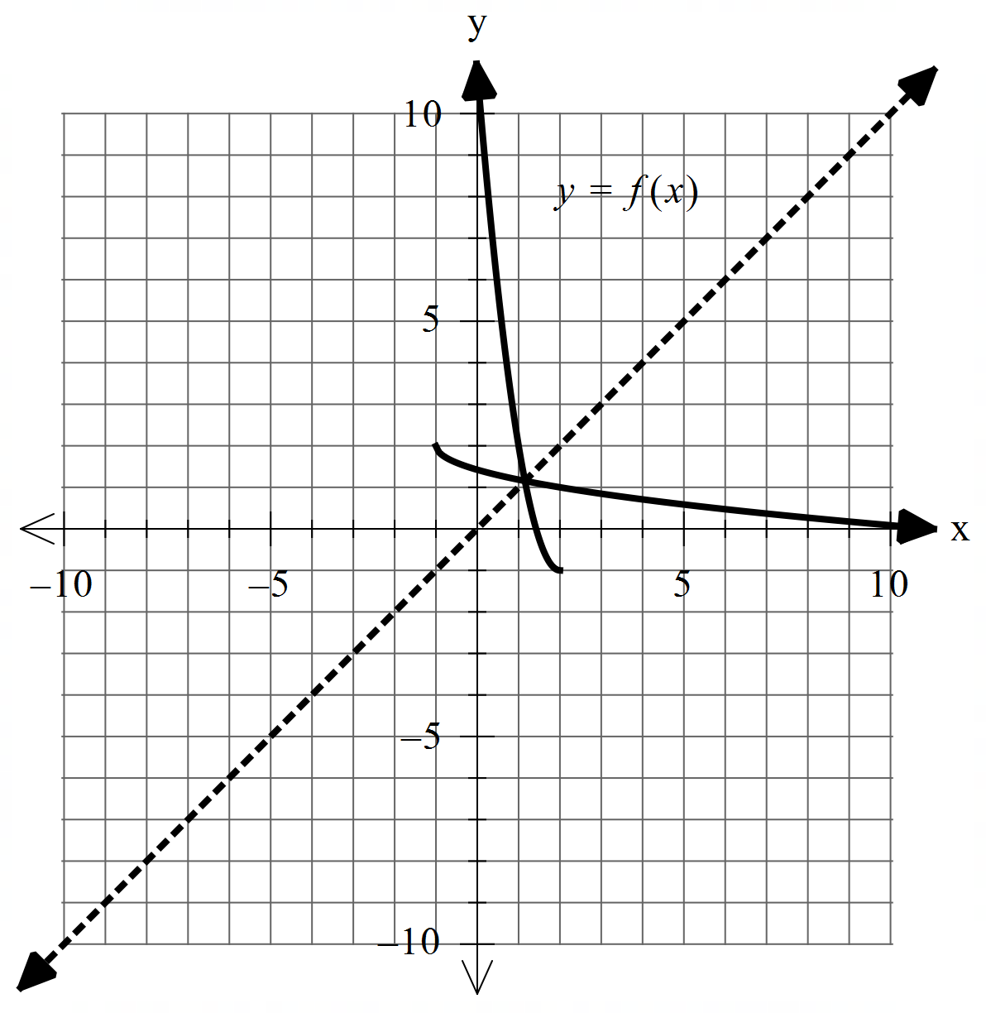Solution
Specific behaviours
P appears reflected in line y=x
P correct endpoint

b)Determine the rule for and state its domain. (4 marks)
Solution
Specific behaviours
P states domain
P swaps x & y of solves for x
P states inverse rule with two possibilities
P discards positive to give only one rule

Q7 continued.

c) Determine (1 mark)

Solution
Specific behaviours
P states x

d) Determine the exact coordinates, if any, where (3 marks)

Solution
Specific behaviours
P equates to x and solves for two values
P discards the positive value
P states simplified exact coordinates for point

Question 8 (4 marks)

Consider two parallel planes . Plane is given by and plane contains the point .
Show that the distance between the two planes is given by

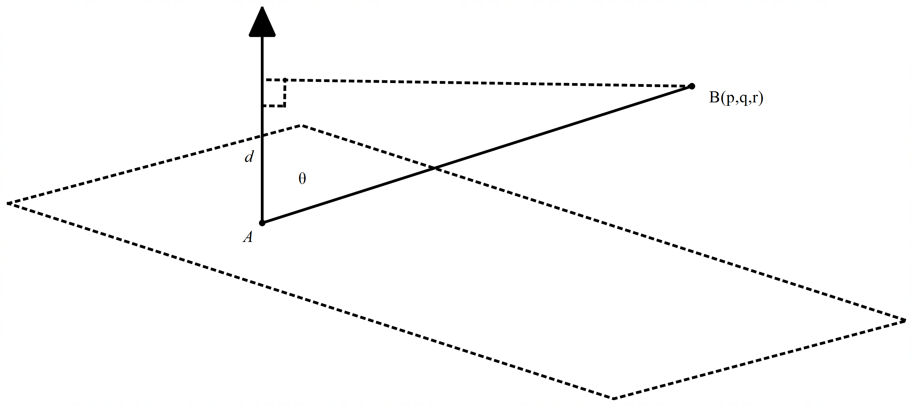
Solution
Specific behaviours
P finds a point on plane
P uses dot product with normal and separation vector
P uses unit normal vector
P shows derivation of final expression
Note: max of 1 mark if separation vector or line equation not used
Note: (p,q,r) is not on first plane and therefore cannot be subs into vector eqn

Additional working space
Question number:

